|  |  |  |  |  |  |  |
| --- | --- | --- | --- | --- | --- | --- |
| **Sanchar Telesystems Limited, Delhi** | | | | | | |
| **S. No.** | **Item Description** | **Total Qty** | **Unit Cost (Rs.)** | **Total Cost (Rs.)** | **Invoice No.** | **Item Received on** |
| **HF Station:** |  | **Yaesu Make** | | |  |  |
| 1 | HF/VHF/UHF Multi band Multi Mode Communication transceiver Model: FT991A | 3 | 1,08,000 | 3,24,000 | G/T/24/0451, dated 30.8.2024 | 19-09-24 |
| 2 | Power supply with battery charger for HF/VHF/UHF equipment Model: 1) BM315 2) DM30 | 3 | 7,000 | 21,000 | G/T/24/0451, dated 30.8.2024 | 19-09-24 |
| 3 | ATU (Antenna Tuner Unit) Model: FC40 | 1 | 28,000 | 28,000 | G/T/24/0451, dated 30.8.2024 | 19-09-24 |
| 4 | HF Wire Antenna (20M/40M with 30 M coax cable) Model: WD330 Make: Diamond | 3 | 15,500 | 46,500 | G/T/24/0670, dated 6.11.2024 | 07-11-24 |
| 5 | HF Multi Band Hex Beam | 3 | 45,000 | 1,35,000 | G/T/24/0875, dated 8.1.2025 | 09-01-25 |
| 20M to 6M with coax cable | 3 | G/T/24/0875, dated 8.1.2025 | 09-01-25 |
| 6 | VHF/UHF Antenna Model:X520 | 3 | 13,500 | 40,500 | G/T/24/0451, dated 30.8.2024 | 19-09-24 |
| 7 | 30M coax cable Model: RG213 | 3 | 2,200 | 6,600 | G/T/24/0451, dated 30.8.2024 | 19-09-24 |
| 8 | 1 No. of 12 Volts Batteries with one float charger | 3 | 4,500 | 13,500 | G/T/24/0451, dated 30.8.2024 | 19-09-24 |
| **VHF/UHF Base Station:** |  |  |  |  |  |  |
| 9 | VHF/UHF Base Station Model: 1) FTM300DR, 2) DR638 | 3 | 34,000 | 1,02,000 | G/T/24/0451, dated 30.8.2024 | 19-09-24 |
| 10 | Power Supply with Battery Charger for VHF/UHF Base Station Model: BM101 | 3 | 3,500 | 10,500 | G/T/24/0451, dated 30.8.2024 | 19-09-24 |
| 11 | Antenna Systems for VHF/UHF (X 300) Make-Diamond | 1 | 10,000 | 10,000 | G/T/24/0670, dated 6.11.2024 | 07-11-24 |
| 12 | 30 M coax cable Model: RG213 | 1 | 2,200 | 2,200 | G/T/24/0451, dated 30.8.2024 | 19-09-24 |
| **VHF/UHF Walkie Talkie:** |  |  |  |  |  |  |
| 13 | VHF/UHF Walkie Talkie (Digital & Analog) | 3 | 35,500 | 1,06,500 | G/T/24/0451, dated 30.8.2024 | 19-09-24 |
| Model 1: FTD50R, Model 2 : MD5 - XGE | G/T/24/0451, dated 30.8.2024 | 19-09-24 |
| 14 | Hot Spot (Zumspot or Open Spot) | 3 | 15,000 | 45,000 | G/T/24/0451, dated 30.8.2024 | 19-09-24 |
| **Digital Communications:** |  |  |  |  |  |  |
| 15 | G-450CDC (Yaesu Rotator) | 1 | 30,000 | 30,000 | G/T/24/0875, dated 8.1.2025 | 09-01-25 |
|  | G5500 (Yaesu Rotators) | 1 | 63,000 | 63,000 | G/T/24/0875, dated 8.1.2025 | 09-01-25 |
| 16 | Antenna Analyzer (HF/VHF/UHF) | 1 | 10,000 | 10,000 | G/T/24/0670, dated 6.11.2024 | 07-11-24 |
| 17 | Kenwood VHF Digital hand held Radio (NX-1200DM3) with std. Accessrey. | 2 | 17,500 | 35,000 | G/T/24/0451, dated 30.8.2024 | 19-09-24 |
| 18 | Programming Software and programming cable for NX-1200DM3 Radio | 1 | 10,000 | 10,000 | G/T/24/0451, dated 30.8.2024 | 19-09-24 |
| 19 | Installation Charges without installation material for all three sites. (at VCE Hyd., VPS Hyd., VPC Banganapalli) | 3 | 35,000 | 35,000 | G/T/24/0875, dated 8.1.2025 | 09-01-25 |
| 20 | RG-213 Co-Axial Cable & Connectors 30 Mtrs | 2 | 2,200 | 4,400 | G/T/24/01021, dated 9.2.2025 | 22-02-25 |
|  | Courier Charges | - | - | 500 | G/T/24/01021, dated 9.2.2025 | 22-02-25 |
| **Total (Rs.):** | | | | **10,74,300** | | |
| **GST @18% (Rs.):** | | | | **1,93,374** | | |
| **Grand total (Rs.):** | | | | **12,67,674** | | |

**Purchased from External other than Saral Sanchar**

|  |  |  |  |  |  |  |
| --- | --- | --- | --- | --- | --- | --- |
| **S.No.** | **Item** | **Invoice No / Date** | **Qty** | **Total** | **Item Received on** | **Purchase From** |
| 1 | Laser Jet Pro MFP 4104dw with wifi printer | LKOI-922, Dated 7-11-2024 | 1 | 34,180 | 13.11.2024 | Amazon |
| 2 | Book: HAM Radio for Dummies | BOM5- 5824720, Dated 7-11-2024 | 1 | 2,636 | 13.11.2024 | Amazon |
| 3 | Books:  1. How to Setup and operate your ham radio  2. HAM Radio exam preparation | XIHG-69878, Dated 7-11-2024 | 2 | 6,703 | 13.11.2024 | Amazon |
| 4 | Book: ARRL Extra Class License Manual | IN-2868, Dated 7-11-2024 | 1 | 4,613.84 | 12.12.2024 | Amazon |
| 5 | TP Link Wifi 6 AX1500 mbps smart wifi | BOM7-2094834, dated 30.12.2024 | 1 | 2,999.01 | 3.1.2025 | Amazon |
| 6 | Beofeng UV-13 Pro Walkie Talkie (set of 3) | FARB4W2500008890, dated 30.12.2024 | 1 | 10,579 | 10.1.2025 | Flipkart |
| 7 | Beofeng UV-13 Pro Walkie Talkie | FATGEL2500000307, dated 30.12.2024 | 1 | 3,590 | 10.1.2025 | Flipkart |
| 8 | Asus AX3000 Dual Band Wifi 6 Smart Wifi Router | W/24-25/Jan/214 | 2 | 20,393 | 10.1.2025 | Prime ABGB |
| 9 | Alfa AWUS036AXML | 57899, DATED 8.1.2025 | 2 | 10774.72 | 16.1.2025 | Fab.to.Lab |
| 10 | 12 FEET Sturctural mast | INV5, dated 16.1.2025 | 1 | 14160 | 16.1.2025 | LVEN |
| 11 | Connectors | INV3, dated 16.1.2025 | 10 | 1,770 | 16.1.2025 | LVEN |
| 12 | BDHT81593 8-Piece Steel Hex key | HYD8-3691044, dated 22.1.2025 | 1 | 176 | 23.1.2025 | Amazon |
| 13 | ACHRO Open End 12 pcs Long Combination Spanner Set | HYD8-3691044, dated 22.1.2025 | 1 | 630 | 23.1.2025 | Amazon |
| 14 | ACHRO 919 Universal Tool Kit Set  (6 Pcs Screwdriver Set & 12 Pcs Spanner Set, 8-inch Plier) | HYD8-3691044, dated 22.1.2025 | 1 | 869 | 23.1.2025 | Amazon |
| 15 | Morse Code Transmitter and CPO | 0219, dated 17.1.2025 | 1 | 1,782 | 29.1.2025 | Samaksha Tech, Bengaluru |
| 16 | 1.0 SQMM X 8 Core Shielded Flexible Cable 200 mtrs | 0901, dated 18.02.2025 | 200 mts | 24,544 | 18.2.2025 | Apex Electrical, Hyd. |
| 17 | MicroFox 50 Combo | 48771, dated 8.1.2025 | 2 | 29,669.98 | 8.2.2025 | Byonics, USA |
| 18 | Q-100 Antenna Kit |  | 1 | 98,530.00 |  | Lven ,AP |
| **Total Rs.** | | | | **2,68,600** |  |  |

**Saral Sanchar Bills**

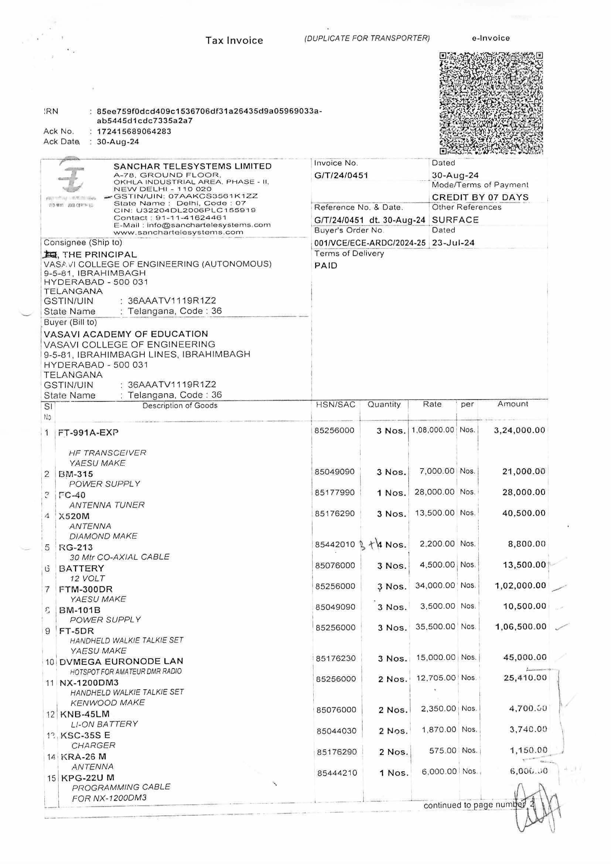

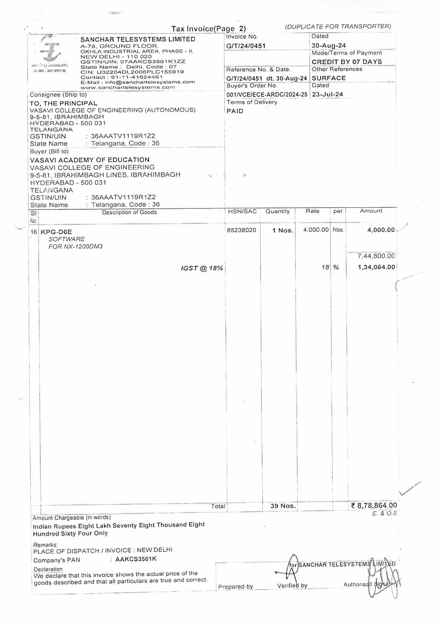

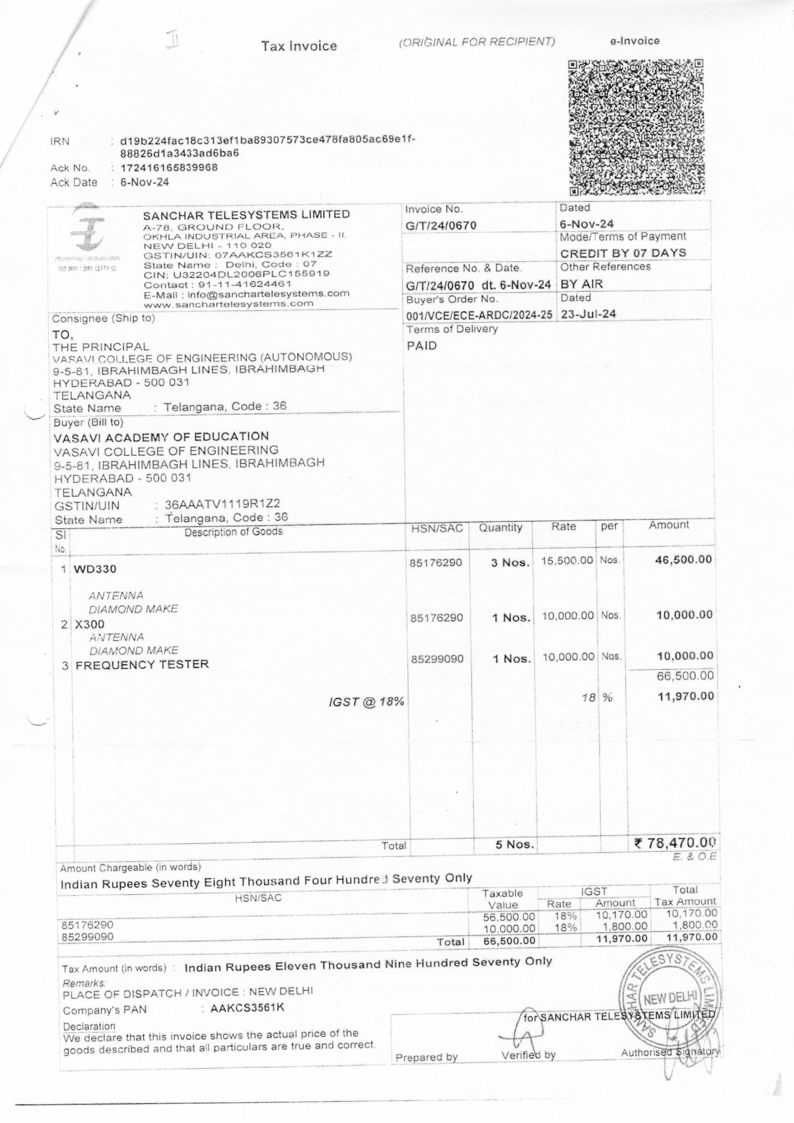

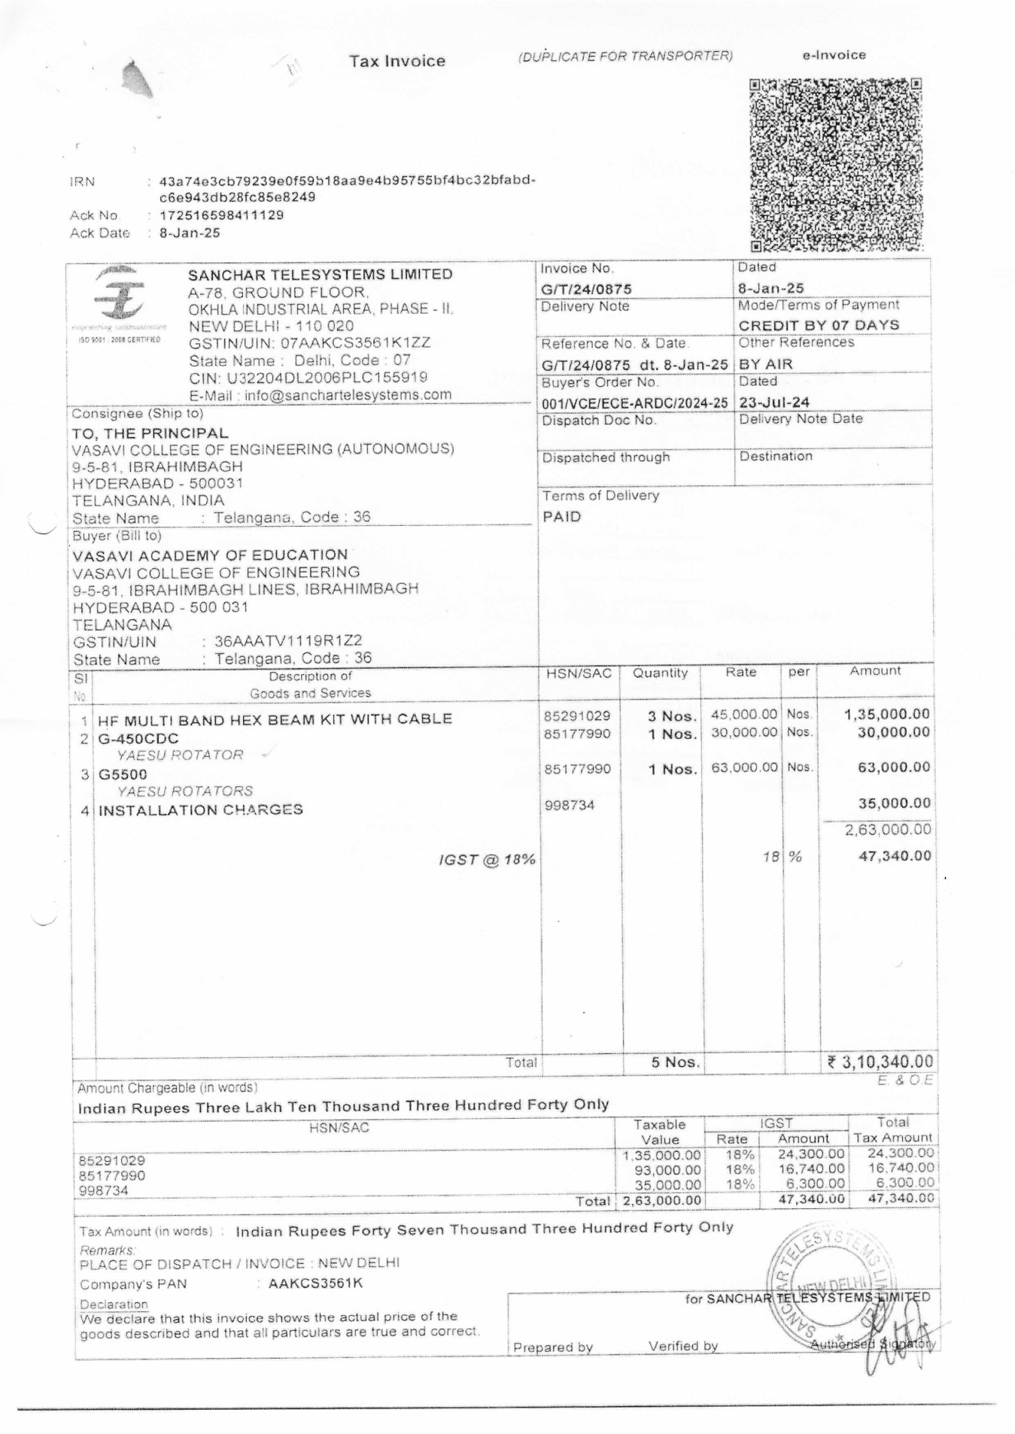

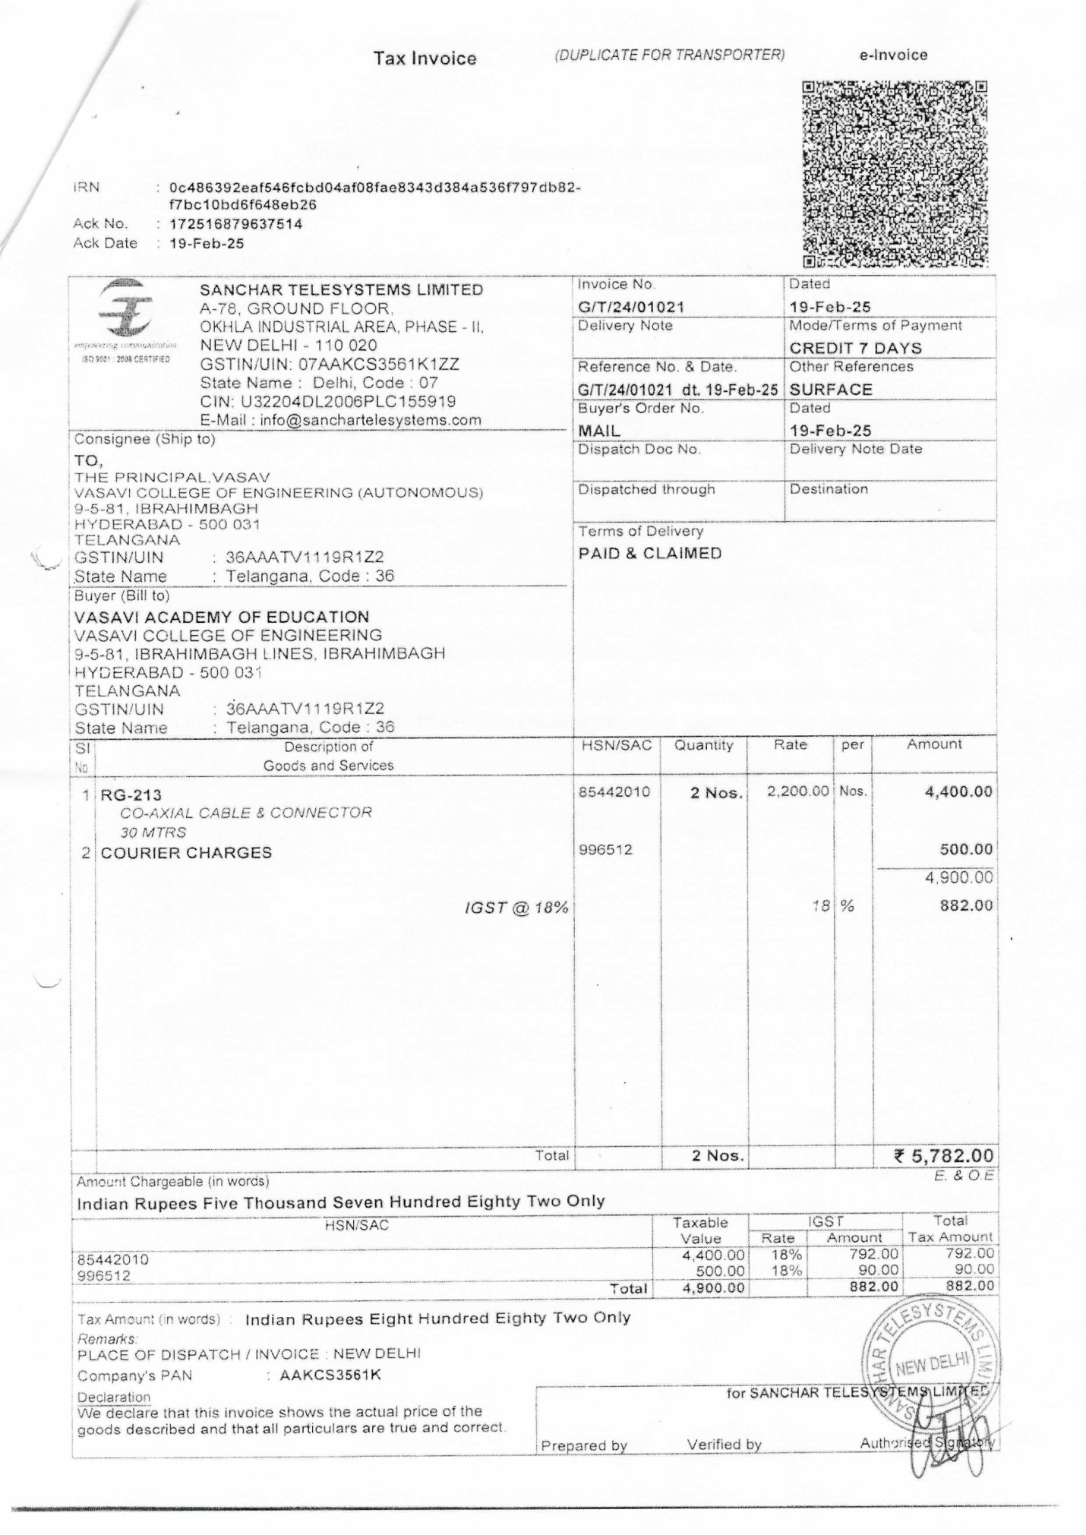

**EXTERNAL BILLS**



